Submitted To: Sir Fahad Satti

Submitted By: Hussnain Waris…05357

Umer Ahmad Mehtab...05905

Class: BESE-4A

Date: 5-01-2016

Date

WEB ENGINEERING

PROJECT REPORT

## PROJECT TITLE: P2P ECOMMERCE

## PROJECT SCOPE:

The aim of this project is to reduce poverty among people by giving them a platform where they can add Ads of their handicrafts. We observe that people having skills aren’t able to sale their items due to lack of market and awareness. In our society there are a lot of people who are fond of art and creativity so this platform will enable them to buy such items while on the other hand will enable the artists to do publicity of their products.

## PROJECT DOMAIN:

E-commerce

## DESCRIPTION:

* There are basically 3 functionalities in this web portal.
* 1st the user is able to view different products by different artists with details mentioned. He/she is able to contact them through their telephone numbers provided in the description.
* 2nd functionality is for the artists to post an ad of their handicraft. It’s a simple form which allows them to post a free ad on our portal.
* 3rd functionality is for the sponsored ads. If the artist wants his/her ad to be visible all the time and also shown at the top of the portal then he/she can buy a sponsored ad which he can do by paying 1$ for the ad but this is not necessary to post the ad.

## FUNCTIONALITY:

* The admin is able to sign in the module of p2p ecommerce by a username and password where he keeps the record of the ads and is able to maintain and delete the ads whenever he wants.
* The artist can post the ad and can make it sponsored if he wants.
* The people looking for handicrafts can surf through the website and see the products.

## REQUIREMENT ANALYSIS:

A survey was conducted for the sake of requirement gathering. Following responses were collected:

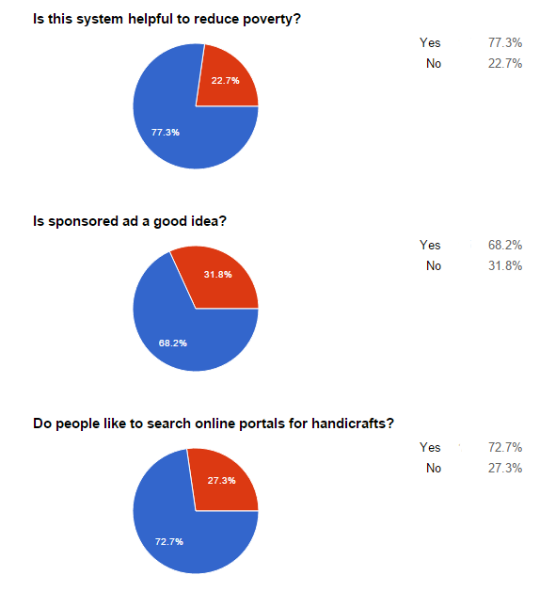

## INTEGRATION DETAILS:

* Signup and login module is handled by one group, they provided us with a basic sign up module for the admin who can delete and maintains the checks of the ads. So if admin wants to login the module he has to login through this module.
* Databases were handles by one group, we provided basic queries and fields of our database. The basic fields of our database include admin credentials, photos, names, descriptions, price, cell number etc.
* Session maintenance is controlled by one group which makes sure that our session is maintained and our specific details of the user are being passed to the database.
* For the sponsored ads our form redirects to the payment module where the user has to pay 1$ for the sponsored ad.

## TECHNOLOGIES USED:

* PHP, HTML5, JavaScript, CSS3, Bootstrap, jQuery

## PROBLEMS FACED:

* Integration with all the modules was a tough job as we haven’t experienced it before but it was worth it.
* Time delays by other members for their modules.
* Lack of coordination.
* Time management.